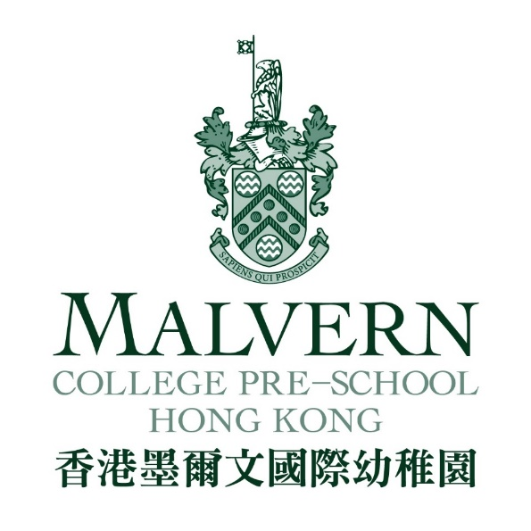
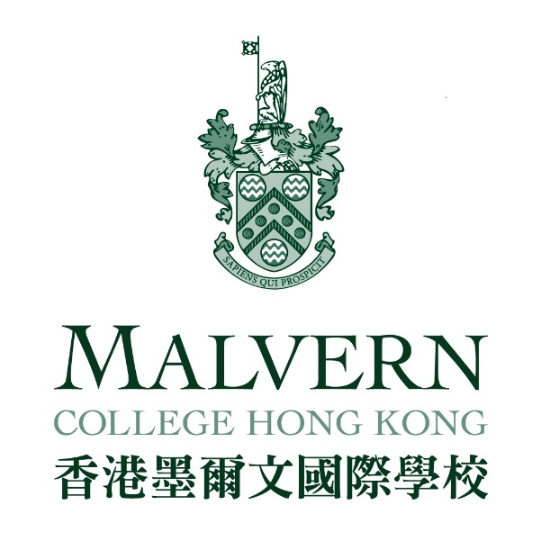

JOB APPLICATION FORM
(Administrative Posts)

JOB APPLICATION FORM
(please upload a recent photo here)

Please fill in this form ensuring all sections are complete. The information is required to ascertain your suitability for interview and is also required under Child Protection regulations. Failure to complete the form fully may delay or hinder your application.

POST APPLIED FOR:

PERSONAL DETAILS

Prefix:  (Mr/Mrs/Ms) |  | Surname: |  | First Name:
 |  | (Must be same as the name on passport)
Date of birth: | (dd-mm-yyyy) |  | Nationality: |  | Passport/ID Number:
Contact Numbers | Mobile |  |  | Email:
 | Home |  |  | Skype ID:  (for interview purpose)
 | Address

CURRENT EMPLOYMENT

Employer  (Name and address) | Post Held | Dates of Employment  (mmm/yyyy) | Reason for Leaving
 |  | to
Brief description of duties of current post:
Monthly basic salary:
Fringe benefits:
Period of Notice Required:

PREVIOUS EMPLOYMENT
Employer  (Name and address) | Post Held | Dates of Employment  (mmm/yyyy) | Reason for Leaving
 |  | to
 |  | to
 |  | to
 |  | to
 |  | to

GAPS IN EMPLOYMENT HISTORY

If there are any gaps in your employment history e.g. sabbaticals or looking after children, please provide details and dates:

EDUCATION HISTORY
College/Universities  (name and country) | Qualifications gained  (include level of degree) | Awarding Body | Date  (mm/yyyy)

Secondary School (name and country) | Qualifications gained  (including grade) | Awarding Body | Date  (mm/yyyy)

PROFESSONAL TRAINING/QUALIFIATION ATTENED
Course/Conference | Qualification/Certificate | Date  (mm/yyyy)

VOCATIONAL SKILLS/TRAINING IN PROGRESS
Subject | Qualifications sought | Date commenced | Date studies expected to finish

AUTHORIZATION FOR JOB REFERENCE CHECK

Please provide contact details of three referees from your direct supervisor of different employers stated in the section of “Previous Employment”. These people must not be your family members

Referee 1
Name:
Job Title:
Company/Organization:
Contact Number:
Email address:
Professional Relationship with the Applicant:

Referee 2
Name:
Job Title:
Company/Organization:
Contact Number:
Email address:
Professional Relationship with the Applicant:

Referee 3
Name:
Job Title:
Company/Organization:
Contact Number:
Email address:
Professional Relationship with the Applicant:

I hereby give my consent to Malvern College Hong Kong / Malvern College Pre-School to contact the above referees for job reference check.

Name of Applicant: Signature:

DISCLOSURE
Please note that all convictions, cautions and bind-overs, including those regarded as ‘spent’ must be declared. Applicants must not have been disqualified from working with children in any jurisdiction, and should not be subject to any sanctions imposed by a regulatory body.

Have you been convicted by the courts of any country of any criminal offence?
YES NO

Is there any relevant court action pending against you in any country?
YES NO

Have you ever received a caution, reprimand or final warning from the police in any country?
YES NO

Have you been disqualified from working with children in any country or jurisdiction?
YES NO

If answering "YES" to any of the questions above, please provide details on a separate sheet and send this in a sealed envelope marked "confidential" with your application form.

Please state below any family or close relationships with current employees of Malvern College, Malvern College Chengdu, any other Malvern College-branded school anywhere in the world, or Babylon Education:

- I confirm that the information I have given on this application form is true and correct to the best of my knowledge.
- I understand that providing false information is an offence which could result in my application being rejected or (if the false information comes to light after my appointment) summary dismissal and may amount to a criminal offence.
- I consent to the College processing the information given on this form, including any 'sensitive' information, as may be necessary during the recruitment and selection process.
- I consent to the College making direct contact with the people specified as my referees to verify the reference.
- I consent to the College sharing the information in this application and any related information with relevant staff at Malvern College UK

Signed: Date:

PLEASE RETURN YOUR COMPLETED APPLICATION FORM, TOGETHER WITH A RESUME TO THE HUMAN RESOURCES DEPARTMENT: hr@malverncollege.org.hk

